

**Standard Operating Procedures**

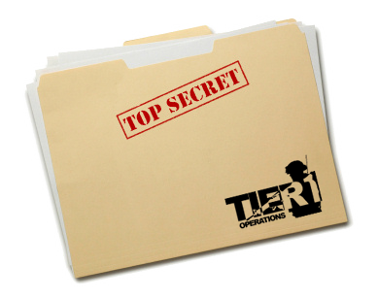

Contents

[1. Basic Infantry 4](#_Toc367182397)

[A. Fireteam Members 4](#_Toc367182398)

[B. Formations and Sectors 4](#_Toc367182399)

[C. Basic Infantry Range 8](#_Toc367182400)

[D. AT Range 9](#_Toc367182401)

[E. Grenade Range 10](#_Toc367182402)

[F. Communications 10](#_Toc367182403)

[G. Medical Emergencies 11](#_Toc367182404)

[2. Advanced Infantry 12](#_Toc367182405)

[A. Formations and Sectors 12](#_Toc367182406)

[B. Immediate Action Drills 12](#_Toc367182407)

[C. Buddy Team Bounding Overwatch 13](#_Toc367182408)

[3. Squad 14](#_Toc367182409)

[A. Layout 14](#_Toc367182410)

[B. Squad Movement 15](#_Toc367182411)

[C. Formations and Sectors 15](#_Toc367182412)

[D. Immediate Action Drills 19](#_Toc367182413)

[E. Bounding Overwatch 19](#_Toc367182414)

[F. Communications 19](#_Toc367182415)

[G. Medical Emergencies 20](#_Toc367182416)

[4. Basic Communications 21](#_Toc367182417)

[A. ACRE Controls 21](#_Toc367182418)

[B. The Short Range Radio 22](#_Toc367182419)

[C. The Long Range Radios 23](#_Toc367182420)

[D. Radio Protocol 25](#_Toc367182421)

[E. Map Reading and Marking 26](#_Toc367182422)

[5. Motorized 32](#_Toc367182423)

[A. Title 1 32](#_Toc367182424)

[B. Title 2 32](#_Toc367182425)

[6. Mechanized 33](#_Toc367182426)

[A. Title 1 33](#_Toc367182427)

[B. Title 2 33](#_Toc367182428)

# Basic Infantry

This section will mostly cover you as an individual soldier and your gear. It will also explain the basics of the medical system, radio operations and fireteam formations.

## Fireteam Members

The smallest unit in the Tier 1 platoon is the Fireteam. Each fireteam consists of 4 members, who each have a number, specific task and position within the team.

1. The Fireteam Leader (FTL) C:\Users\Arnout\Pictures\Inkscape\ArmA 3 Unit Marker TL_S.png  
   He leads the rest of the team, decides which formation to use, has binoculars and an underbarrel grenade launcher. Most experienced member of the team.
2. The Automatic Rifleman (AR) C:\Users\Arnout\Pictures\Inkscape\ArmA 3 Unit Marker AR_S.png  
   He carries the Automatic rifle, basically a light machine gun. He has the most firepower in the team.
3. The Assistant Automatic Rifleman (AAR) C:\Users\Arnout\Pictures\Inkscape\ArmA 3 Unit Marker Basic_S.png  
   He carries extra ammo for the AR and has a rifle with a medium range optic, to help the AR with spotting targets and hitting them at longer ranges.
4. The Rifleman AT (RAT)C:\Users\Arnout\Pictures\Inkscape\ArmA 3 Unit Marker RAT_S.png  
   Junior member of the team, carries the AT launcher if it is available.

Every fireteam consists of two buddy teams. Buddy team red and buddy team blue.  
Team Red: FTL and RAT (nr. 1 and nr. 4)  
Team Blue: AR and AAR (nr. 2 and nr. 3)

You should always keep an eye on your buddy. If he gets shot, it is your job to inform the FTL and drag your buddy to safety and stabilize him. (See 'G. Medical Emergencies').

These numbers also indicate the chain of command within the fireteam. Should the fireteam lead (nr. 1) die, the automatic rifleman (nr. 2) will take over, etc.

## Formations and Sectors

The fireteam is able to form 3 basic formations. In each formation, every fireteam member has a fixed position and a sector to cover. While the fireteam moves you should keep an eye on this sector and when the fireteam halts, you should turn towards your sector and cover it.

Within a fireteam each member is responsible for covering a sector. Each fireteam has 4 sectors: front, right, left and rear. These depend on the direction of movement. Front is always the last direction that the fireteam was moving in.

Our fireteam numbering makes it easy to remember which area should be covered by each member.

1. FTL: Covers front
2. AR: Covers right
3. AAR: Covers left
4. RAT: Covers rear

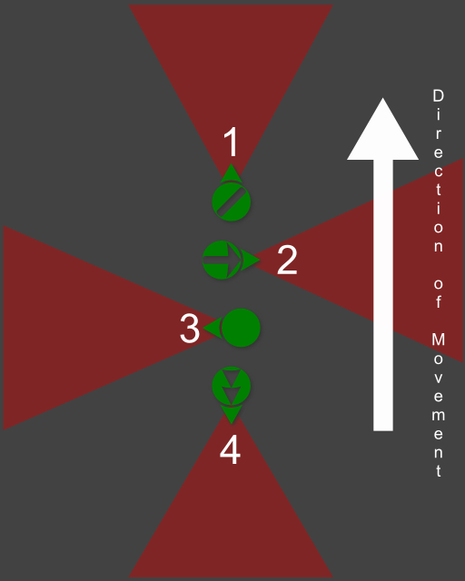Column formation  
Use: when marching through safe areas or in urban areas with little room to maneuver.

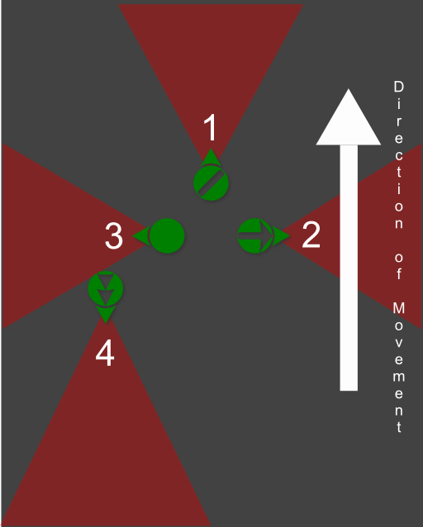Wedge Formation  
Use: in the open when enemy contact is likely. Note that the Rifleman (RAT) nr. 4, can either be on the left or right side of this formation. This depends on the terrain.

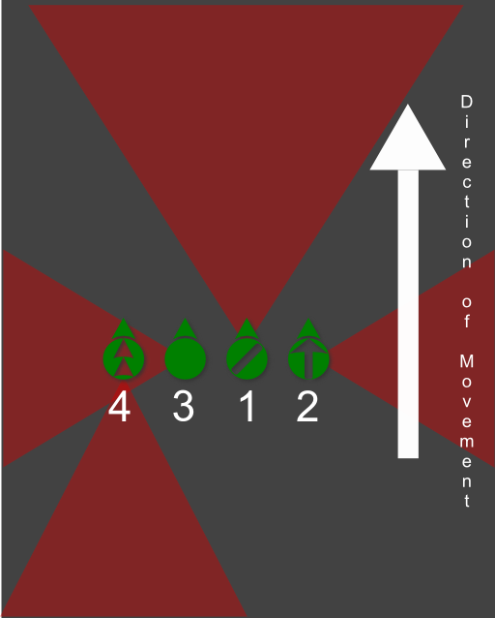Line Formation  
Use: when assaulting enemy positions, mostly used for the base of fire elements.  
Note: When in line most units will focus towards the front, however you are still theoretically supposed to check your sector. It seems wrong in the line formation, however we maintain the same sectors for each unit to make it easier to remember.  
Note that the Rifleman (RAT) nr. 4, can either be on the left or right side of this formation. This depends on the terrain.

## Basic Infantry Range

The basic infantry range will help you to familiarize yourself with the movement in ArmA 3.

Start at the flag and move from position to position where you will shoot every practice target once.

Positions:

1. Prone firing
2. High stance
3. Leaning around a corner
4. Crouching
5. Moving and shooting

Tip: reload while running from one position to the next.

Note that ArmA 3 features additional stances by pressing the CTRL key together with the WSAD keys.

## AT Range

In every fireteam the RAT carries a PCML. This is a guided rocket launcher that can be used to destroy enemy vehicles or fortifications.

In order to use it effectively some knowledge of the weapon is required.

The PCML is guided, just aim directly at the target, wait for the launcher to lock on and then you are ready to fire. In order to fire at fortifications, use the picture below. In the screenshot below you can see the PCML's sight and the ranges marked on the sights. If you can correctly determine the range to the target, all you need to do is line up the sights correctly and fire.

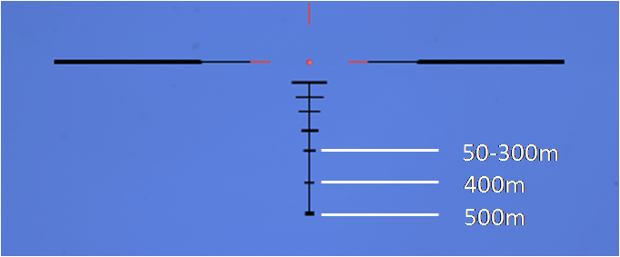

The rifleman will not equip his AT until the teamleader tells him to equip it, this is to prevent any misfires of the AT which can take out an entire fireteam in one shot.

The procedure for firing AT is as follows:  
The teamleader will tell his RAT to prepare the AT and designate the target.  
For example: 'Rifleman prepare AT', 'Target, enemy APC at 230 degrees, range 300 meters'.

The RAT will equip his AT launcher and locate the target. Next he will clear his backblast area. The backblast is basically the overpressure and debris that leaves the rear of the AT launcher when it is fired, so the potential to hit friendlies is large.  
The backblast area is about 25 meters long behind the launcher and consists of about a 30° angle.  
The RAT yells: 'Clear backblast!' and looks over his shoulder to check that there is no one behind him, his buddy will tell him when his backblast is clear. He then announces 'Rocket, Rocket, Rocket!' and launches the missile on the third time he says 'Rocket'.

## Grenade Range

In ArmA 3 the G key allows you to instantly throw a grenade. This can be very useful but also extremely dangerous. You can quickly lob a grenade through a window to take down enemies hiding inside a building. But one press of a button can also cause you to drop a grenade in the middle of your fireteam.

The Tier 1 grenade range is a good way to practice using grenades and get to know their destructive power.

## Communications

Tier 1 makes use of the ACRE mod combined with Teamspeak 3 to make communication in game both easier and more realistic.

Your teamspeak push to talk button will allow you to communicate over direct speech in 3D directional audio with everyone that is close enough to you on the virtual battlefield. Using the ACRE radio button (standard CAPS LOCK) combined with you teamspeak push to talk key, will allow you to talk over your currently selected radio.

Within the fireteam you will almost exclusively use the direct chat and not the radio. The radio will only be used for information that is important for the squad, such as reports on enemy positions, status updates, contact reports, casualties, etc.

#### AN/PRC-343

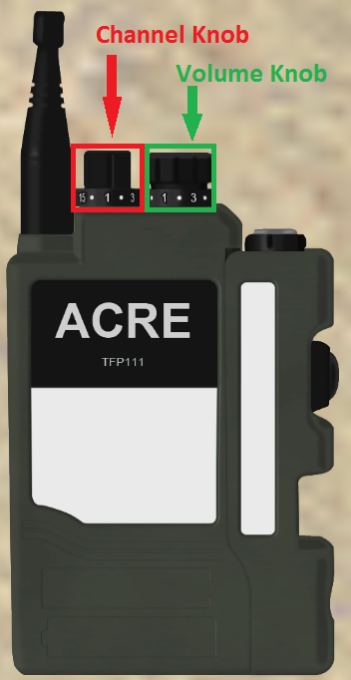Every infantry unit is equipped with at least one radio, the AN/PRC-343.The AN/PRC-343 is a short range radio (about 800 meters range with direct line of sight) for squad level communications. Each squad has a separate radio channel.

1. Alpha squad
2. Bravo squad
3. Charlie squad
4. Platoon attachment
5. Platoon lead

To talk on your currently selected radio you hold down the CAPS LOCK key.  
Note that you cannot hear any incoming transmissions while you are sending yourself.

You open your radio by pressing the CTRL + SHIFT + X key combination. Your radio will open up and there will be two knobs on the top. One changes channels, the other one changes the volume. Left clicking will turn the knob up, right clicking will turn it down.

Pressing CTRL + SHIFT + left, right or up arrow key, will change the current radio to only the left, right or both ears.

Switching radios can be done by pressing the CTRL + SHIFT + A/S keys.

Note that all ACRE radios are affected both by range and the terrain. If you are behind a mountain you will not be able to reach the unit behind it, even when it is within range.

## Medical Emergencies

Someone will get hit eventually, in this case you need to know what to do.

Tier 1 missions make use of a number of custom scripts to augment the medic system in ArmA 3.

If you get hit, you will either be lightly wounded or heavily wounded/unconscious.

If one of your fireteam members gets shot and goes unconscious your first job is to report it to the fireteam leader. Next, check if it is your buddy.

If it is your buddy, pop smoke, try to move his body in a safe position (this can be done by using the **'Drag'** option in the action menu). Then stabilize him (action menu: **'Stabilize'**). Remember that your own safety is always more important than your downed team member. It's better to have 1 man down, than 2 men down.

If it is not your buddy, set up cover for your team members to secure the wounded man. Provide covering fire if necessary. Do NOT stare at the body and anyone stabilizing him, you should be looking for possible threats.

If lightly wounded, and not within immediate danger of dying, wait until the firefight ends and then inform your leader that you need medical assistance. Most of the time, you will have to move to the medic in this case.

# Advanced Infantry

This section will give further information on fireteam formations, immediate action drills, buddy team bounding overwatch.

## Formations and Sectors

During advanced infantry training you will practice movement in formation with an entire fireteam. If you need a refresher on the different formations see Chapter 1 Basic Infantry.

Also pay attention to the STHUD, a very useful addon that allows you to see where your fireteam members are, their names and also where north, east, south and west is.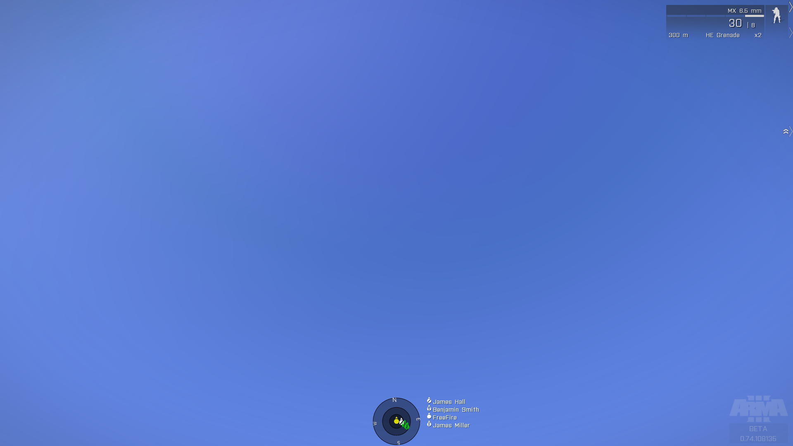

The inner circle is 10 meters, the next one 25 and the last one 50. remember to try and keep the spacing between you and your team mates at 5 meters to prevent multiple casualties due to explosives.

## Immediate Action Drills

#### Contact Drill (Immediate Assault Drill)

When to use the contact drill:   
Enemies are nearby and pose an immediate threat to you or friendlies. This drill is also used when your team comes under fire.

How to do the contact drill:  
When you spot the immediate threat you start with the key word: **'Contact'** followed by a direction **'Front, Front-Right, Right, etc.'**. The fireteam will then face in that direction and start suppressing that area, whether they can see a target or not. The fireteam leader will send a contact report over the radio to the rest of the squad as soon as possible. Once the threat is dealt with, all fireteam members should cover their sectors again.

#### Freeze Drill (Immediate Halt Drill)

When to use the freeze drill:  
You have spotted a (possible) threat that is not an immediate threat to you or friendlies and requires further investigation.

How to do the freeze drill:  
When you spot the threat, call out **'Freeze'** on the radio.And then continue over direct chat with the **'Type of threat', 'direction'** and **'range'** (these do not need to be very accurate). The entire team will hold and face their sectors. Except for the fireteam leader, he will try to find the threat and then report it accurately to the squad leader with **'Unit that is reporting the threat'** **'Type of threat', 'compass direction'** and **'range'.**

## Buddy Team Bounding Overwatch

Bounding overwatch is a movement technique that allows a fireteam to constantly keep half of its members suppressing the target and the other half moving. It can be used both to advance towards an enemy position or to fall back. It can also be useful to cross large dangerous areas.

Bounding is done in buddy teams (red and blue), see Chapter 1: Basic Infantry for more info about the buddy teams. The team leader will announce **'Bounding Overwatch', 'destination or direction' 'Team that moves first'**. For example: 'Bounding Overwatch, to the large hangar to the north, Blue bound/move'.

The first team (here blue) will then move up 15 meters and hold (if possible in cover), start suppressing the enemy and call over direct chat **'Blue Set'** the other ream (red) will then move up and pass the first team calling out **'Passing left/right'**, they will then hold 15 meters in front of the first team, start suppressing and announce **'Red Set'**. Blue team will then move again, etc. until the target is reached. The teamleader will then announce 'Regroup' to end the Bounding Overwatch.

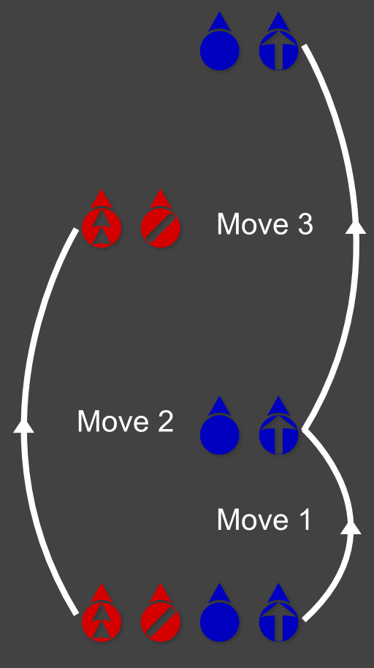Note that it is important to not move further than 15 meters, or you will not be able to hear your team mates over the sound of the gunfire.

# Squad

This section will cover all information and procedures for the Tier 1 squad.

## Layout

The standard infantry squad consists of 4 elements. For Alpha squad this would be:

1. The Squad Lead element (ASL)
2. Fireteam 1 (A1)
3. Fireteam 2 (A2)
4. Fireteam 3 (A3)

Note: every squad is designated by a letter according to the Nato alphabet (Alpha, Bravo, etc.)

For information on the fireteams see Chapter 1: Basic Infantry and Chapter 2: Advanced Infantry.

The squad lead element contains 3 members:

* The Squad Leader (SL) C:\Users\Arnout\Pictures\Inkscape\ArmA 3 Unit Marker TL_S.png  
  He leads the entire squad, decides which formation to use, has binoculars, a grenade launcher with smoke for marking targets or providing cover.
* The Medic (ME) C:\Users\Arnout\Pictures\Inkscape\Arma 3\ArmA 3 Unit Marker Medic_S.png  
  He is responsible for all medical emergencies in the squad, has limited ammunition and iron sights. He mostly keeps his head low and stays with the Squad Leader until he is needed.
* The Radioman / Radio Operator (RO) C:\Users\Arnout\Pictures\Inkscape\ArmA 3 Unit Marker Basic_S.png  
  He carries the long range radio and is responsible for all the communications between the squad (leader) and all other elements, such as Platoon Lead, other squads and supporting elements. He also functions as a Forward Air Controller (FAC) and a Forward Observer (FO).

The chain of command within the squad also follows the numbers of the different elements:

1. SL
2. FT1 - FTL (1-1)
3. FT2 - FTL (2-1)
4. FT3 - FTL (3-1)
5. FT1 - AR (1-2)
6. FT2 - AR (2-2)
7. Etc.

The Medic and Radioman will always move to the new squad leader and stick with him.

## Squad Movement

An important difference between squad and fireteam movement is that the squad leader does not lead from the front. He will be slightly behind his troops or in the middle of the formation. He focuses more on leading his team and guiding their fire and movement rather than actually shooting.

The Squad Leader will mark the route that the squad should follow and designate Observation Points (OP) and Assault Points (AP). The FTL of Fireteam 1 - who is at the front of the formation - will be the pathfinder. He chooses the actual route according to the terrain. He also announces on the squad radio when the formation moves out or when it holds using the phrases: **'1, Moving (out)', '1, Holding'**.

## Formations and Sectors

Just like the Fireteam, the Squad can form 3 formations. In each formation every fireteam has a fixed position and a designated sector to cover. The 4 sectors are again: front, right, left and rear.

1. FT 1 covers front
2. FT 2 covers right
3. FT 3 covers left (except when in column formation then they cover rear)
4. SL covers rear

The Squad Leader decides which formation to use, the fireteams will normally go into the same formation as the squad (so when the squad moves in wedge formation the fireteams will do the same with their 4 members). However the FTL can decide to change his fireteam's formation if needed.

Note that the sector covering on the squad level is not the same as on the fireteam level. Every fireteam member is still responsible for their sector as designated in Chapter 1: Basic Infantry. The fireteam should however pay extra attention to their assigned sector.

#### Column

Use: when marching through safe areas or in urban areas with little room to maneuver.  
Note: Fireteam 3 does not cover the left, in column formation they cover the rear, SL covers left.

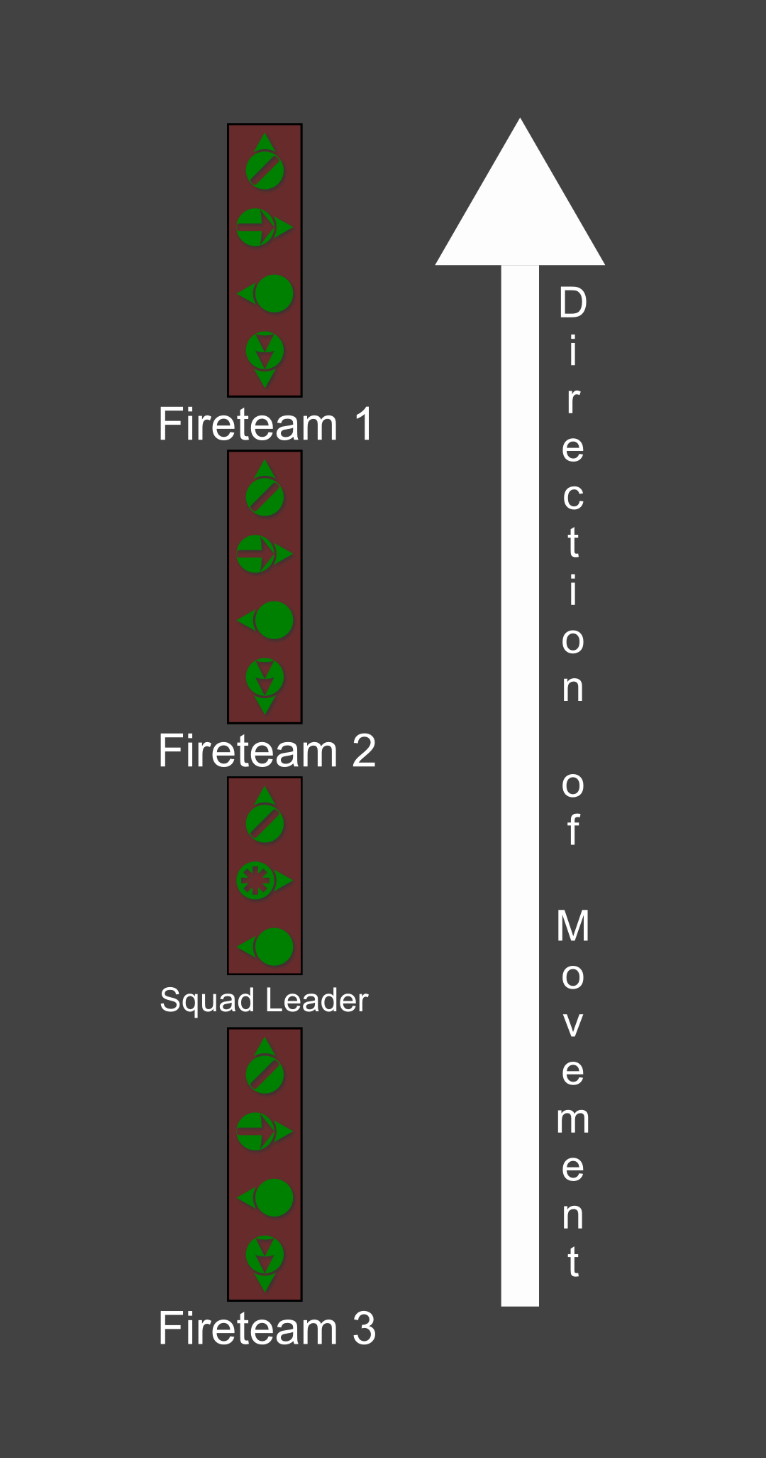

#### Wedge

Use: in the open when enemy contact is likely. Note that the Rifleman (RAT) nr. 4, can either be on the left or right side of this formation. This depends on the terrain.

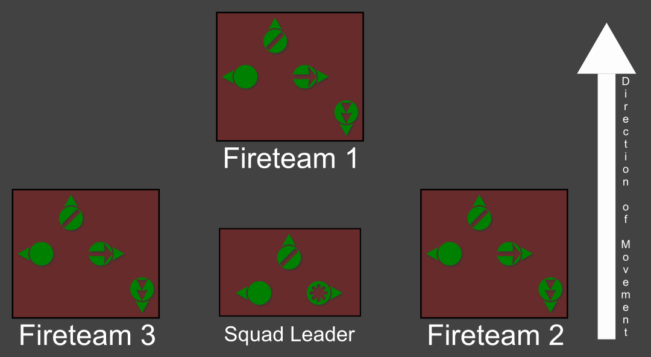

#### Line

Use: when assaulting enemy positions, mostly used for the base of fire elements.

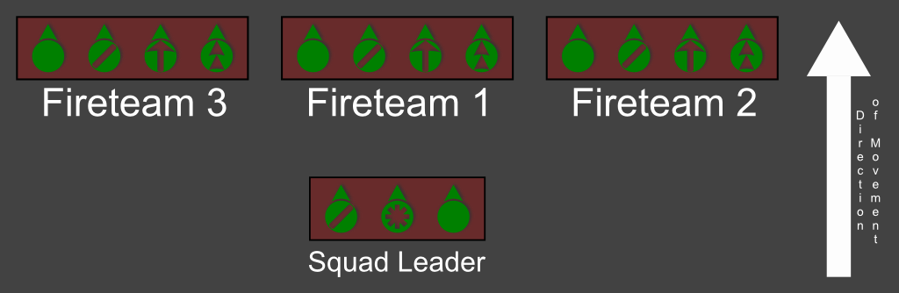

## Immediate Action Drills

#### Immediate Assault Drill (Contact Drill)

When one of the fireteams comes under fire it will execute its contact drill. The teamleader of that fireteam will report the situation to the squad leader as soon as possible ('The unit that is sending the report', 'Type of threat', 'compass direction' if possible otherwise he uses 'front, left, right, rear' , 'range' if possible). The Squad Leader will then decide what to do (fall back, flanking maneuver, ...).

#### Immediate Halt Drill (Freeze Drill)

When one of the fireteams executes the freeze drill they will call out **'Freeze'** on the squad radio. All fireteams will then hold position, check their sectors and wait for further orders. The fireteam that called out freeze will continue its report to the squad leader with **'The unit that is sending the report', 'Type of threat', 'compass direction' , 'range'**.

See Chapter 2: Advanced infantry for more information on the Immediate Action Drills

## Bounding Overwatch

Idea: successive bounding 1/2 and 3/lead.

## Communications

Every squad member has an AN/PRC-343 short range radio. This is used for all the communication within the squad. There are 5 major categories of communication on the squad radio:

* Orders and Feedback:  
  The Squad Leader will give many different orders on the squad radio channel. Fireteam leaders need to give feedback on the orders that are meant for them (copy, understood, repeat the orders, ...).  
  For more info see Chapter X: Basic Communications.
* Moving and Holding  
  The Fireteam lead that currently leads the formation (most often FT 1) will announce on the radio when he moves out or holds to the squad leader and other elements.
* Communication for bounding overwatch see E. Bounding Overwatch
* Contact reports see D. Immediate Action Drills
* Status reports:  
  Medical emergencies  
   Ammo status, SITREP (situation report), troops ready or in position

## Medical Emergencies

#### Man Wounded

When a fireteam member gets wounded he will move to cover and use his first aid kit if possible and report it to his teamleader. The teamleader will request for a medic as soon as the firefight is over and the area is secure.

#### Man Unconscious

When a fireteam member goes unconscious his teammates will secure and stabilize him. (see Chapter 1 Basic Infantry for more information). The teamleader will request a medic as soon as the wounded team member is brought to safety and stabilized. The fireteam will hold position and provide cover for the medic, who will be sent over by the Squad Leader.

#### Team Unconscious

Should an entire team go unconscious, then it's up to the squad leader to send another fireteam to help it out. There are no real guidelines on how to do this, improvise and make do.

# Basic Communications

## ACRE Controls

**Left Shift + Left Control + X** = Access Current Radio  
**Left Shift + Left Control + A or S** = Switch between ACRE Radios  
**Left Shift + Left Alt. + Q** = ACRE Interaction Menu: Access Radio Rack in Vehicle (ALL helicopters have an AN/PRC-117 radio in them.  
**Left** **Shift + Left Alt. + E** = ACRE Self Interaction Menu: Access Radio Functions  
**Left Shift + Left Control + (Up Arrow, Left Arrow, or Right Arrow)** = Set which ear current radio receives transmissions through.  
**Left Shift + Left Alt+ 1** = PTT Preset: Talk on 343  
**Left Shift + Left Alt+ 2** = PTT Preset: Talk on (Command Radio)

## The Short Range Radio

Tier 1 makes use of the ACRE mod combined with Teamspeak 3 to make communication in game both easier and more realistic.

Your teamspeak push to talk button will allow you to communicate over direct speech in 3D directional audio with everyone that is close enough to you on the virtual battlefield. Using the ACRE radio button (standard CAPS LOCK) will allow you to talk over your currently selected radio.

Within the fireteam you will almost exclusively use the direct chat and not the radio. The radio will only be used for information that is important for the squad, such as reports on enemy positions, status updates, contact reports, casualties, etc.

#### AN/PRC-343

Every infantry unit is equipped with at least one radio, the AN/PRC-343.The AN/PRC-343 is a short range radio (about 800 meters range with direct line of sight) for squad level communications. Each squad has a separate radio channel.

1. Alpha squad
2. Bravo squad
3. Charlie squad
4. Platoon attachment
5. Platoon lead  
   15-16. Shadow 1 and 2

To talk on your currently selected radio you hold down the CAPS LOCK key.  
Note that you cannot hear any incoming transmissions while you are sending yourself.

You open your radio by pressing the CTRL + SHIFT + X key combination. Your radio will open up and there will be two knobs on the top. One changes channels, the other one changes the volume. Left clicking will turn the knob up, right clicking will turn it down.

## The Long Range Radios

#### AN/PRC-117:

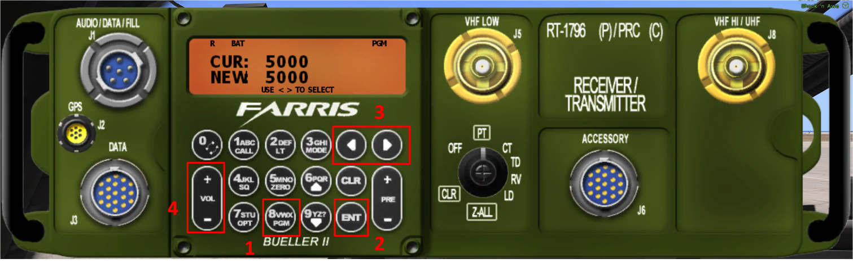

To set maximum range on the 117F, click the #8 (PGM) button (**1**) and then click ENT (Enter) (**2**). You will see the five settings modes, the first one blinking:

**FREQ CS DATA  
SQL POWER NAME**

Click the Left or Right arrow buttons (**3**) until POWER is blinking, then click the ENT (Enter) button (**2**). Now you will see a familiar display:

**CUR: 5000  
NEW: 5000**

Click the left or right arrow buttons to adjust **NEW** to max range (**20,000**), then press ENT (Enter) (**2**).

Changing channels is done with the PRE + and - buttons.

Finally, you can also change the volume with the VOL buttons (**4**).

#### AN/PRC-152

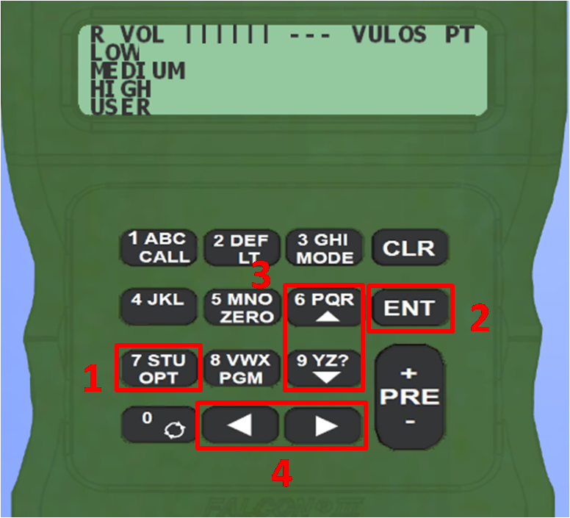

To set the maximum range on the 152, click the #7 (OPT) button (**1**) and then click ENT (**2**).  
Four power settings will appear as shown above. **LOW** will be blinking. Use the vertical arrow keys (#6 and #9) (**3**) to select **HIGH** which will then be blinking. Click ENT (**2**). Changing channels is done with the PRE + and - buttons. Finally, you can set the volume by using the horizontal arrow keys (**4**).

## Radio Protocol

#### Words In Voice Procedure

* **Affirm(ative)** — Yes
* **Negative** — No
* **Over** — I have finished talking and I am listening for your reply. Short for "Over to you."
* **Out** — I have finished talking to you and do not expect a reply.
* **Roger /Copy** — I understand what you just said.
* **Wilco** — Will comply (after receiving new directions).
* **Go ahead** or **Send** — Send your transmission.
* **Say again** — Please repeat your last message *(Repeat is only used in US military radio terminology to request additional artillery fire)*
* **Break-Break** — Signals to all listeners on the frequency, the message to follow is priority. Almost always reserved for emergency traffic, CLEAR COMMS!!!
* **Standby** or **Wait one** — Pause for the next transmission. This usually entails staying off the air until the operator returns after a short wait.
* **Callsign-Actual** — Sometimes an individual (generally a superior) may have a person monitor the network for them. Saying "actual" after their callsign asserts you wish to speak to the specific person the callsign is attached to.
* **How copy?** — Used after giving orders. It prompts the other elements to read back the orders that were given.

#### NATO Phonetic Alphabet

<http://en.wikipedia.org/wiki/NATO_phonetic_alphabet>

#### Example Usage (= Establishing Contact/Comms?)

##### **Target Callsign + Source Callsign + Request**

**ALPHA 12:** X-RAY Two-Three, THIS IS ALPHA One-Two, MESSAGE, OVER

**X-RAY 23:** ALPHA One-Two, THIS IS X-RAY Two-Three, SEND OVER

**ALPHA 12:** We are in position and ready to attack, OVER

**X-RAY 23:** Copy, commence attack, OUT

#### Radio Check

**ALPHA 12:** X-RAY Two-Three, THIS IS ALPHA One-Two, RADIO CHECK, OVER

**X-RAY 23:** ALPHA One-Two, THIS IS X-RAY Two-Three, ROGER OUT

#### Contact Report

When reporting the position of enemies, it is very important to do so in a short and clear manner. This allows the lead element to respond swiftly and will give you the upper hand.

Here's how:   
**'The unit that is sending the report', 'Type of threat and how many', 'Compass direction', 'Range', 'Further remarks'.**

* **The unit that is sending the report**This is self-explanatory, the unit you currently belong to.
* **Type of threat and how many**What type the enemy unit is - this could be enemy infantry, a tank, an APC, a car, etc. - followed up by how many of them there are.
* **Compass direction**The compass direction relative to your location. You can also add from which unit this direction is relevant.
* **Range**How far away the enemy unit is from your location. If possible, use an actual number (e.g. 300m), otherwise use "close, medium range, far".
* **Further Remarks**You can add on extra information at the end of your contact report. Useful remarks include: where the enemy is moving, where they are relative to a landmark, what weapons they have, etc.

**Example:** This is Alpha 2, 5 enemy infantry, direction 150 from 2, range 400m, moving south, over.

## Map Reading and Marking

#### Grid References

* The map is divided laterally and longitudinally into a square grid system. The grids are numbered in increasing order from left to right and top to bottom.
* Grid references are read on the longitudinal axis (horizontal - x coordinate) followed by the lateral axis (vertical - y coordinate).
* At the lower levels of zoom, grids display three values per grid. Referencing the grid system at this level will provide a location with an accuracy of **100 m.**
* At the larger levels of zoom, grids display two values per grid. Referencing the grid system at this level will provide a location with an accuracy of 1 km (sometimes referred to as "one klik").
* At the largest levels of zoom, grids display one value per grid. Referencing the grid system at this level will provide a location with an accuracy of 10km (10 kliks).

#### Contour linesC:\Users\Robin\Documents\Documenten Robin\T1\Training\SOP\Basic Comms\Contour Lines.png

Contour lines represent the change in elevation of the map. Closely bunched contour lines therefore indicate a rapid change in elevation, while spread out lines indicate gradual change in elevation. The spacing of contour lines is not indicated and changes depending on zoom level.

#### Range estimation

The main way to estimate the range to a certain target, is by using the map.

To start off, you'll have to be able to find the target on the map. This is usually done by finding landmarks close to the target on your map.

First, aim at the landmark. Next, open your map, find where your element is located using the markers. Place your compass over your marker (you can double click it to make it bigger). Your compass will automatically point to where you are aiming. Observe the terrain to which your compass is pointing and try to find the landmark. Once you've found it, use it as a reference to locate the target. Place a marker on it (see chapter marking).

Now that you have marked the target, you can estimate the range.

If the target is directly to your south, north, east or west, simply count the amount of grids between you and the target. Multiply the amount of grids by 100 and you have the range.

**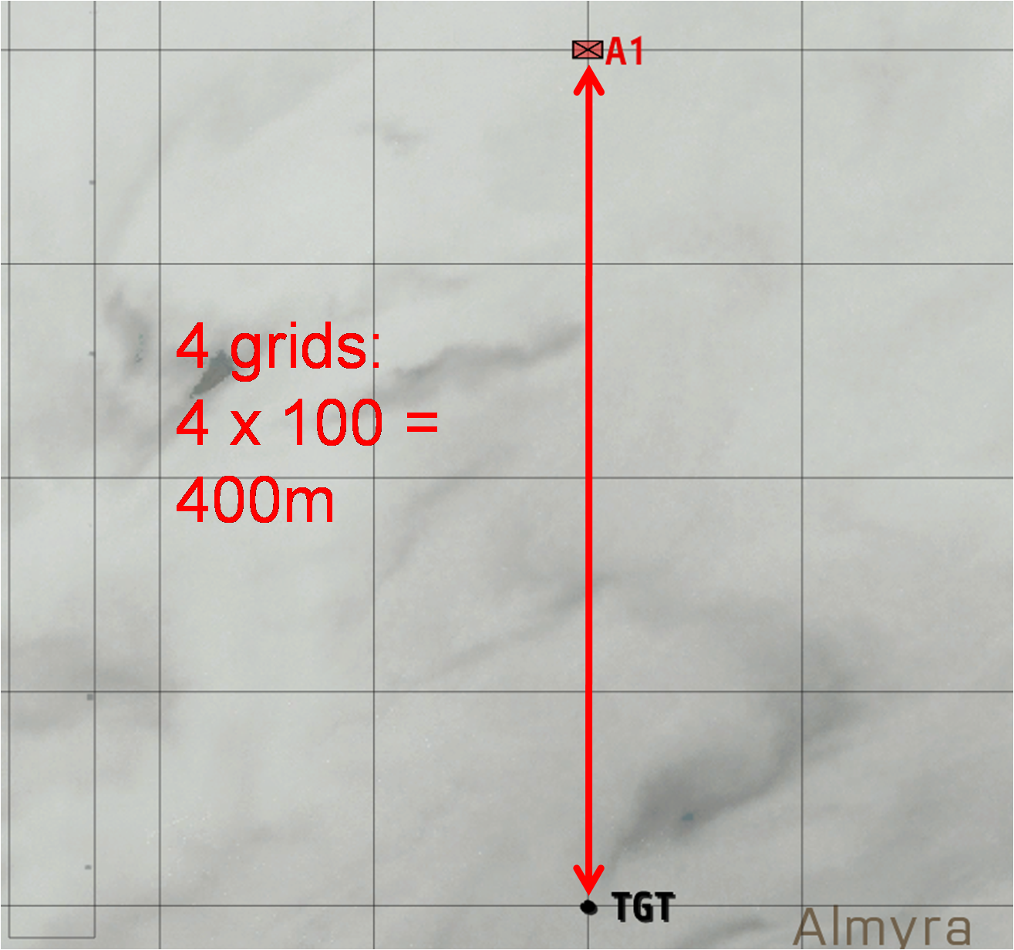**

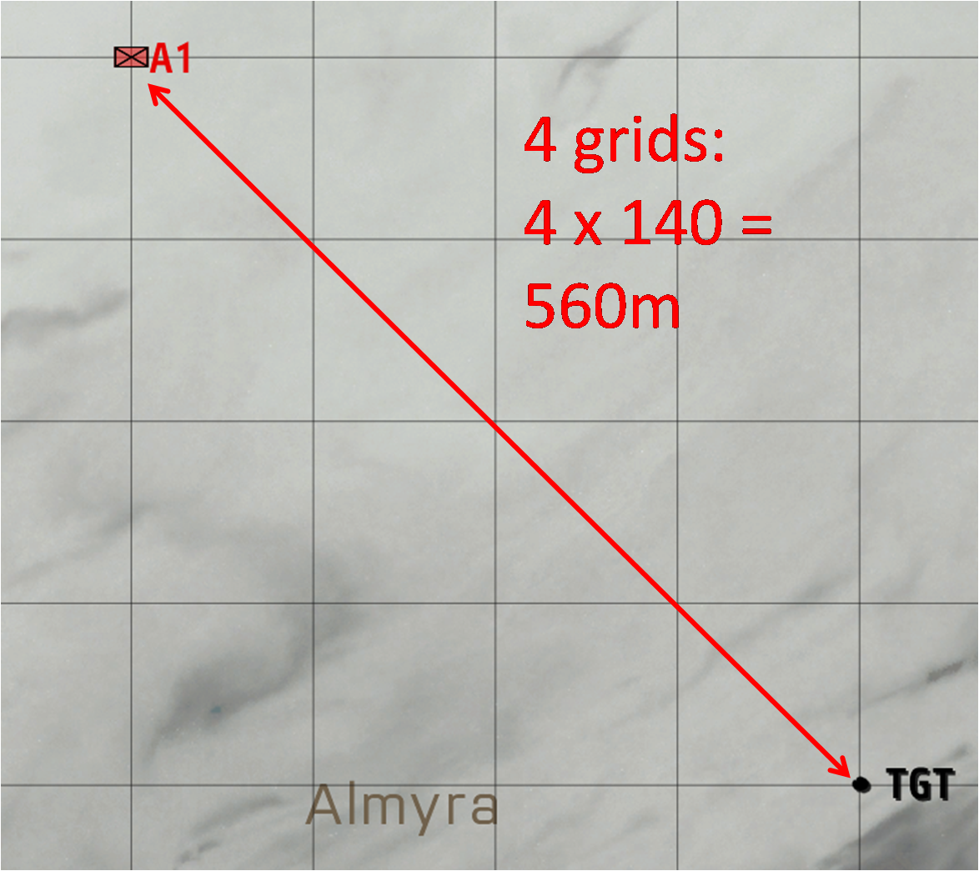If target is directly to your south-east, south-west, north-west, etc., count the amount of grids between you and the target and multiply the amount of grids by 141m.

In all other cases, count the amount of horizontal grids towards your target and the amount of vertical grids and use the Pythagorean theorem (a² = b² + c²)

**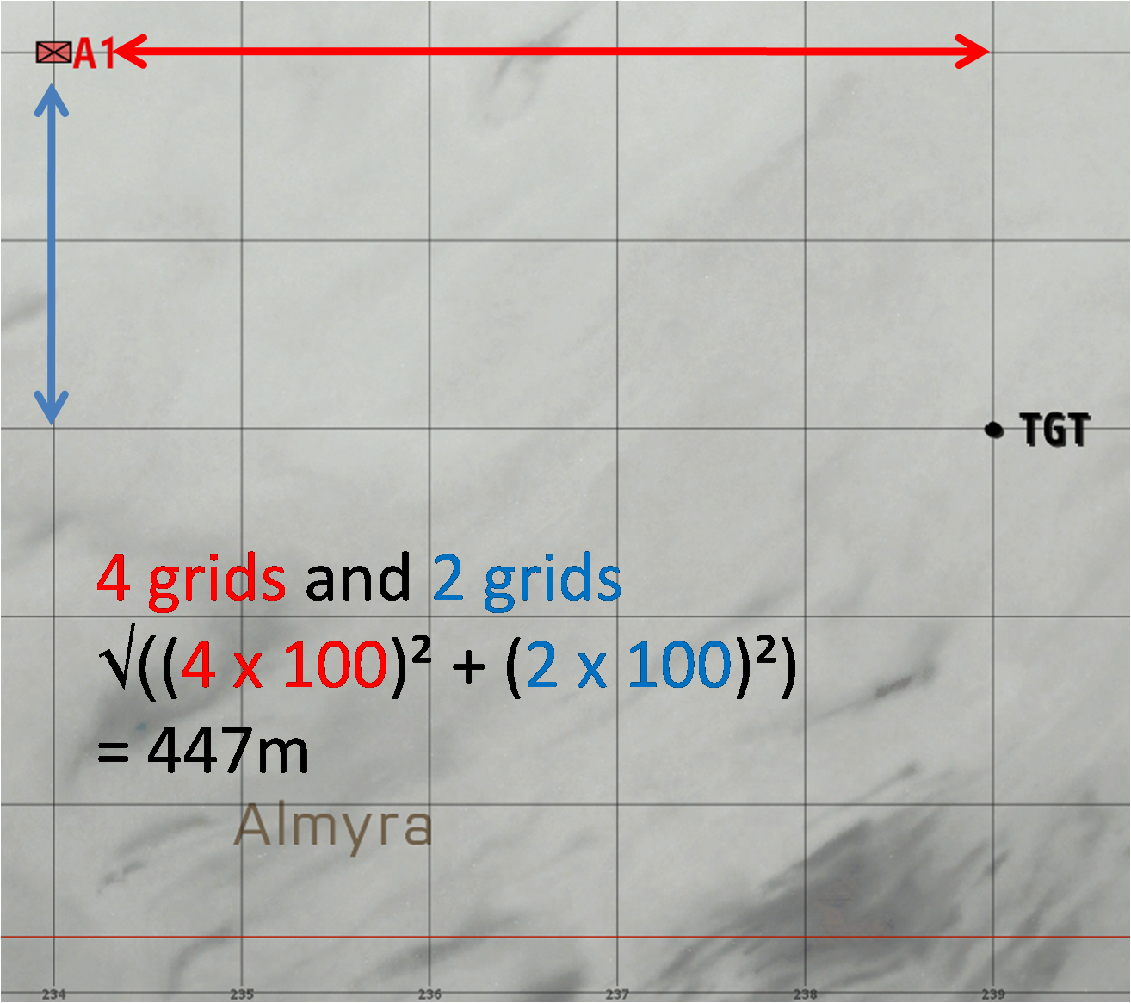**

#### Marking

When marking things on the map, whether it be enemies, waypoints, etc., it's important that you keep the text next to your markers short and clear. In general we have 3 types of markers.

* **Unit markers**  
  These indicate friendly units and will update periodically. They cannot be placed manually.
* 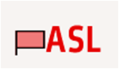**Enemy markers**  
  These indicate enemy units. They are always placed manually and should always be dots. To use dots, double click on the map and press the down arrow key until you reach the dot (11 key presses).

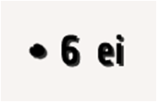

* **Other markers**  
  Every other type of marker. Some commonly used ones: Waypoint (wp), Observation Point (OP), Attack Point (AP).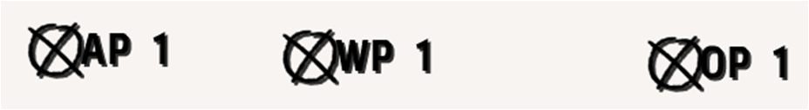

How to mark enemy units: (**Use a dot,) number of enemies, type of unit**

The type of unit can be the following:

* **EI:** Enemy Infantry
* **Veh:** Vehicle
* **Car**
* **APC:** Armoured Personnel Carrier
* **Armor:** APC/Tank
* **UNK:** Unknown
* **AA:** Anti Air
* **Arty:** Artillery

# Motorized

## Title 1

## Title 2

# Mechanized

## Title 1

## Title 2